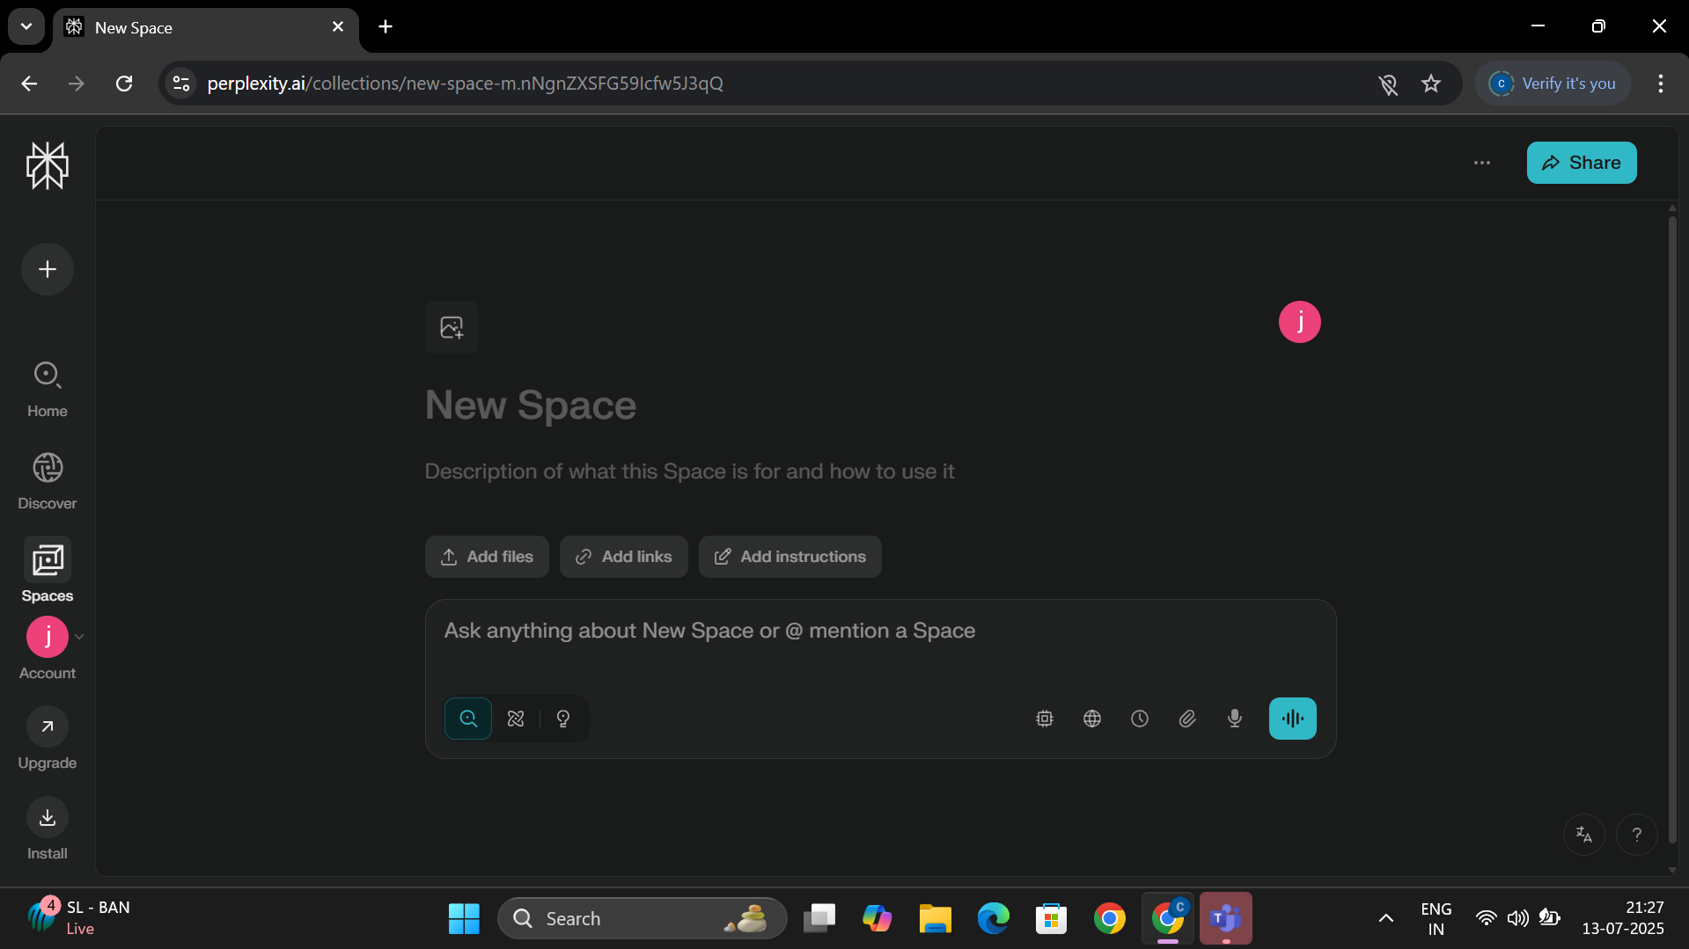

**Perplexity AI** is an advanced conversational search engine and answer platform that leverages large language models (LLMs) to provide direct, well-sourced answers to user queries. Unlike traditional search engines that return a list of links, Perplexity delivers concise, cited responses in natural language, making research and information discovery more efficient and transparent  
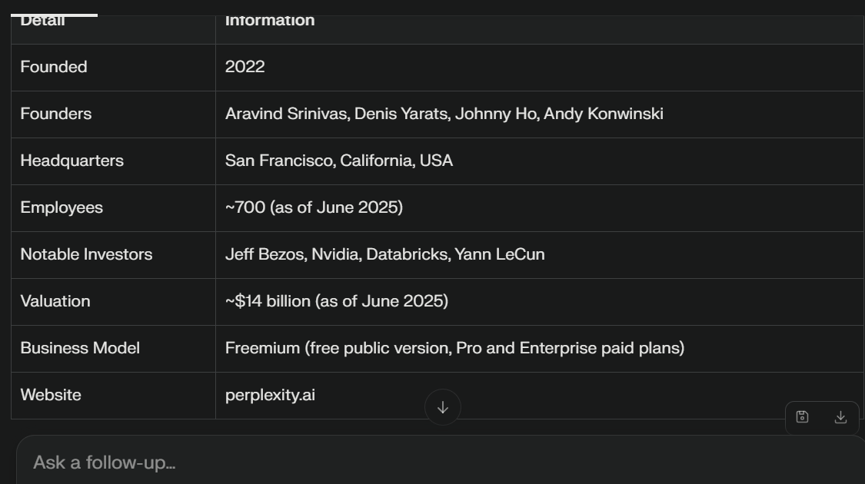

Perplexity is founded by the company **Perplexity AI, Inc.** This privately held company was established in 2022 by Aravind Srinivas, Denis Yarats, Johnny Ho, and Andy Konwinski. It is headquartered in San Francisco, California, United States



